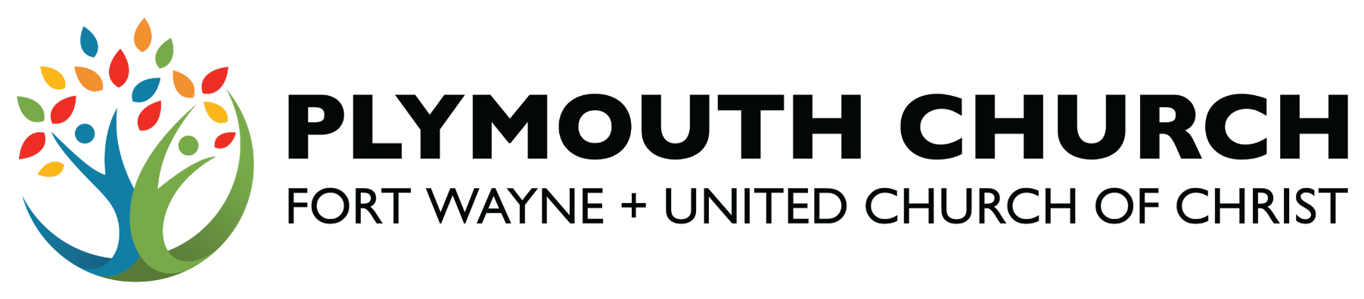

PLYMOUTH CONGREGATIONAL CHURCH
of FORT WAYNE + UNITED CHURCH OF CHRIST
501 West Berry Street + Fort Wayne, IN 46802 + 260.423.9424 + plymouthfw.org

Application for Emma Feigley Mission Funding
(Please type all information)

Date _________________

Name/Organization __________ _______ _________

Email ___ ______________Phone______ _______________

Website URL ______ ______________

Address ______ __________________________________________________

City ________ ____________ State _____ ________________ Zip __ ____

Contact Person ___ _________________ _______

Email _____ ________________ Phone _____________________________

Address ____ ____________________________________

City _______ ________________ State _______________ Zip ___________

Questions: (Please use a separate typed sheet and attach if needed.)

- Describe the mission and/or organization for which you are requesting Emma Feigley Mission funding.

- How will Mission funds be used? Describe the specific project/activity and the population it will serve.

- What is the budget for the project?

- Have you applied to other funding sources to meet your project needs? If so, please list and the amount requested

- The Benevolence Committee requires follow-up reporting of funded Emma Feigley projects, no later than three months after initiation or completion. Reporting should be offered to the committee in writing or, in some cases, oral presentation (pictures of project activities are appreciated). How do you plan on reporting to the committee?

Amount requested ___________ Signature _____ ______ _

Please return completed application to:

Benevolence@plymouthfw.org

Or mail to:

Benevolence Committee
Plymouth Congregational Church
501 West Berry Street
Fort Wayne, IN 46802
Office: (260) 423-9424

Benevolence Committee use only

Amount Funded_______________

Signature _________________________________ Signature _________________________________

Signature _________________________________ Signature _________________________________

Notes:

